RESEARCH STUDY - FEBRUARY 2026
AI FOR AMERICANS FIRST
AI Protectionism, Energy and Semiconductors: US/Europe Divergence Trajectories 2024-2030
Integrated Geostrategy and Economic Analysis - CHAPTER VI
76.9% of global operational AI compute = USA | 1.59x EU/US energy cost (PPP-adjusted) | 3.46:1 US/EU CACI ratio (Power Mode)

Fabrice Pizzi
Universite Paris-Sorbonne
Master 2 Intelligence Economique - Intelligence Warfare
Paris - February 2026 | 7 Chapters | 4 Prospective Scenarios | 3 Geographic Zones
Keywords: artificial intelligence, technological protectionism, semiconductors, export controls, sovereign compute, AI geopolitics, France, United States, China
CHAPTER VI
Consequences for France and Europe
The previous chapters have established the diagnostic (III), the mechanisms (IV) and the possible trajectories (V). This chapter outlines the concrete consequences for French and European actors, distinguishing three levels of analysis: sectoral breakdown (which sectors are most exposed?), differentiation by actor type (large groups, SMEs, startups, public sector), and second-order effects (brain drain, R&D offshoring, normative fragmentation). The analysis relies mainly on scenario A (the most probable) and scenario B (the most severe), while signaling bifurcations specific to scenarios C and D.
6.1 Sectoral analysis: differentiated exposure to compute asymmetry
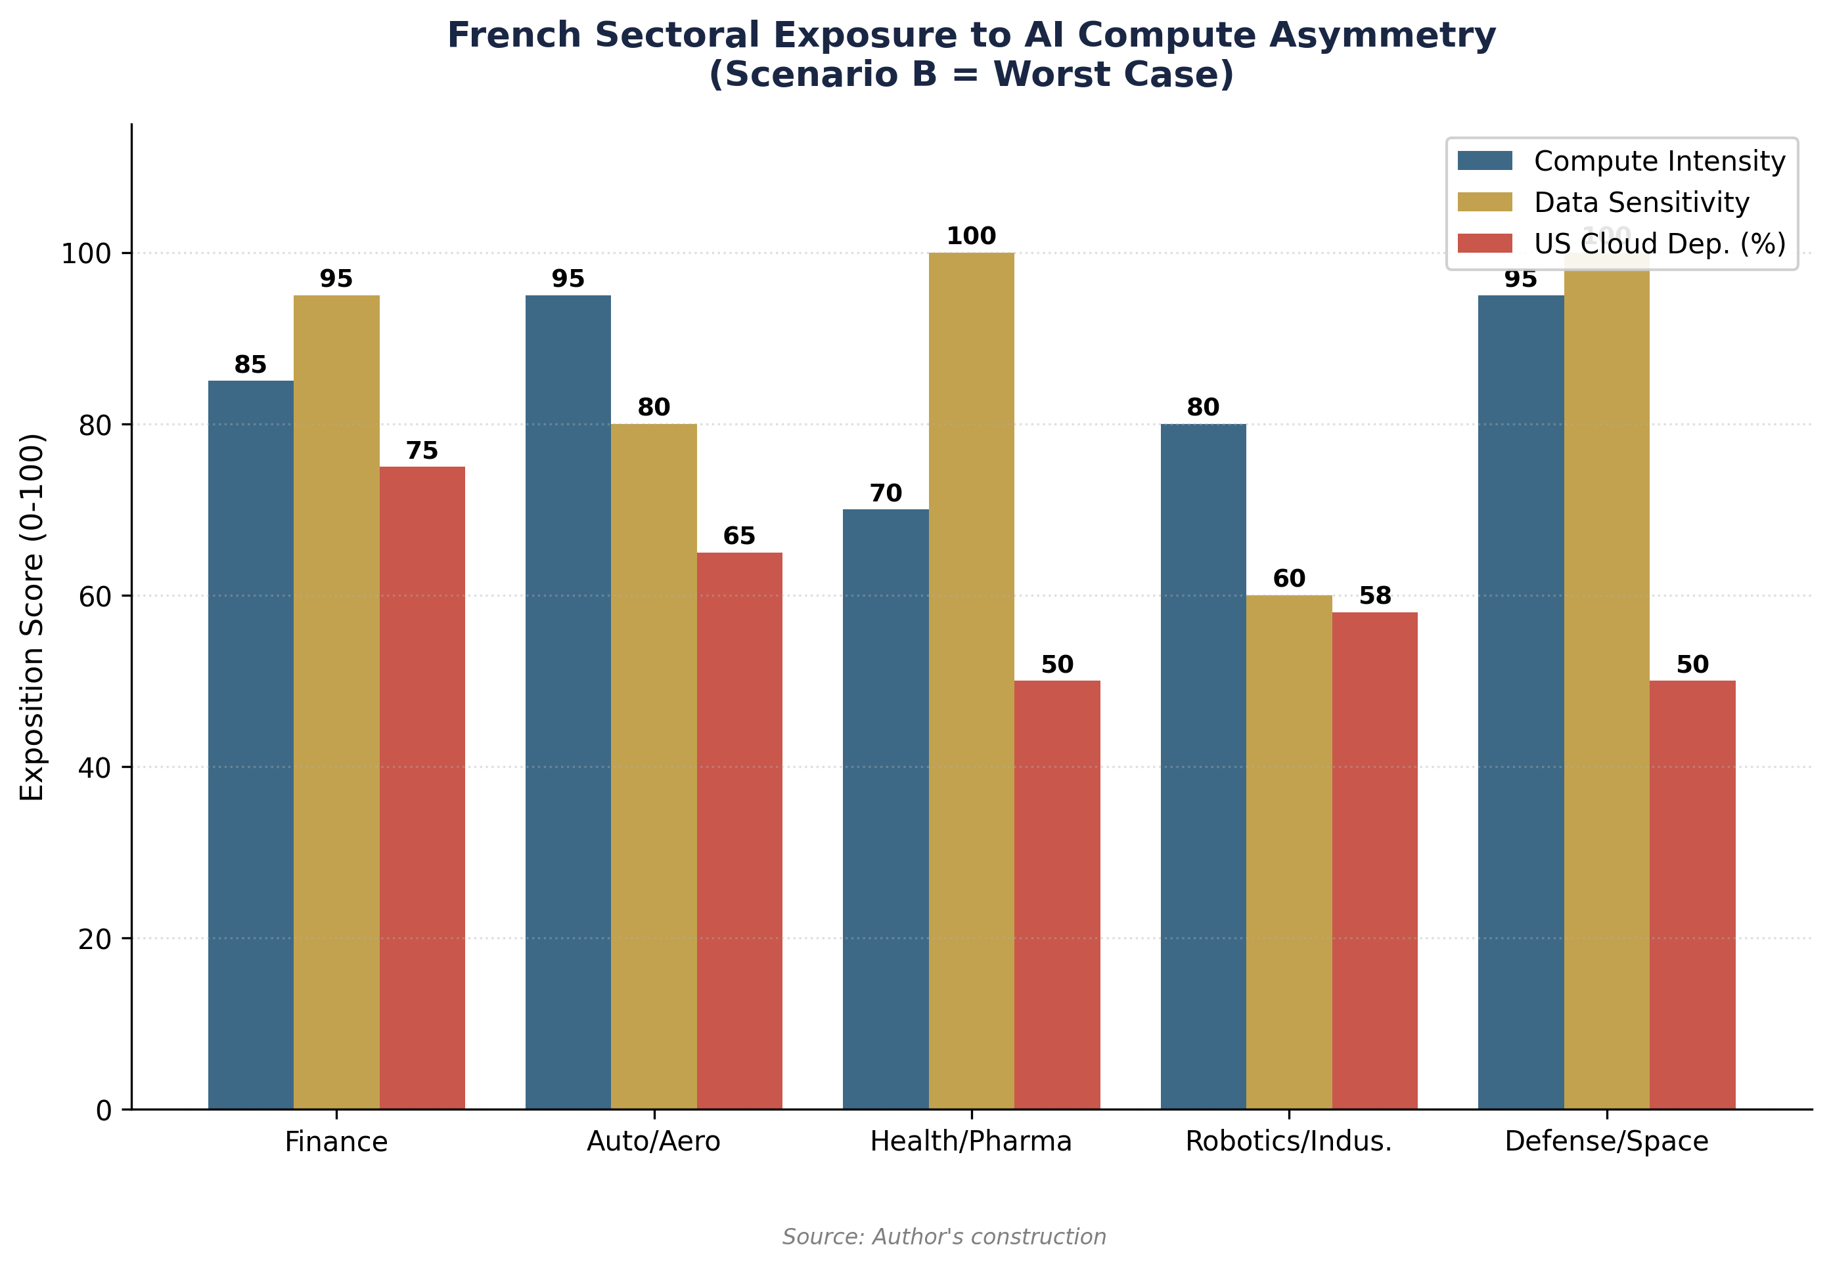

6.1.1 Financial services: advanced dependence
The French financial sector is the most advanced in AI adoption and, paradoxically, the most exposed to the risk of geopolitical vendor lock-in. BNP Paribas, Société Générale, Crédit Agricole, and AXA are massively deploying AI solutions for fraud detection, credit scoring, algorithmic trading, and risk optimization. AXA and BNP Paribas are among the first enterprise customers of Mistral AI in France.[1] These deployments rely largely on US cloud infrastructure (AWS for BNP Paribas, Azure for Société Générale). Productivity gains observed in the global financial sector are among the highest (the IMF cites microeconomic gains of 20 to 40 percent on compliance and analysis tasks), as it is a cognitively intensive and high-wage sector—two factors that maximize the return on investment of automation.[2]
The risk specific to the financial sector is twofold. On one hand, European regulations (DORA, AI Act, GDPR) impose localization and auditability requirements that create tension with the dependence on US cloud: French banks must guarantee that their customers' data is not accessible to US authorities (CLOUD Act), while depending on AWS and Azure for computing power. On the other hand, under scenario B, an increase in the cost of accessing cutting-edge AI cloud would directly hit the most compute-intensive applications (risk models, Monte Carlo simulations, training of specialized LLMs). The productivity gap with US banks (JPMorgan, Goldman Sachs, which each invest several billion a year in AI) would widen by an additional 3 to 5 points per year.


6.1.2 Automotive and aerospace industry: compute-intensive and vulnerable
The European automotive industry has already experienced a revealing precedent: the 2022 semiconductor shortage cost the EU auto sector alone approximately 100 billion euros (Chapter IV). AI transforms this sector on three axes: autonomous driving (training perception models, requiring tens of thousands of GPUs), production optimization (digital twins, predictive maintenance), and assisted design (aerodynamic simulation, virtual crash tests). Stellantis (formerly PSA) signed a 100 million euro partnership with Mistral AI to integrate AI across all its businesses, from transport to logistics.[3]
Aerospace (Airbus, Safran, Thales, Dassault Aviation) presents a similar profile but aggravated by the defense dimension. Complex aerodynamic simulations, fleet predictive maintenance, and the design of autonomous weapons systems are extremely compute-intensive applications. Airbus relies on AWS and Azure for its cloud workloads. Under scenario B, restrictions on advanced GPUs would directly affect simulation capabilities; under scenario D, pressure to repatriate workloads to sovereign infrastructure would create considerable transition costs but would reduce strategic vulnerability.


6.1.3 Healthcare and life sciences: data sovereignty issue
The healthcare sector presents a different vulnerability: compute intensity is lower (except for AI-driven drug discovery, which requires massive GPU clusters), but data sensitivity is maximal. The European Health Data Space (EHDS) strictly regulates the processing of medical data. Sanofi, one of the world's leading pharmaceutical groups, has invested 1 billion dollars in AI partnerships (including OpenAI and Owkin, a French startup specialized in AI for clinical research).[4] Novo Nordisk, although Danish, illustrates the European challenge: more than 8.2 billion dollars in R&D in 2024, with increasing use of AI for human body digital twins and accelerating drug discovery.[5]
The impact of protectionism scenarios here is indirect but structural. If access to cutting-edge GPUs is restricted, AI drug discovery projects (which require model training for several weeks on thousands of GPUs) will be slowed down or offshored to the United States. Owkin, founded in Paris, has already opened offices in New York and could transfer its most compute-intensive workloads there if European costs became prohibitive.


6.1.4 Robotics and manufacturing industry: the energy factor
AI robotics and industrial automation add an additional energy dimension. Training perception and control models for industrial robots is compute-intensive, but it is especially the large-scale deployment of AI-equipped robots (edge computing, embedded inference) that multiplies industrial energy demand. The convergence of data centers + edge compute + robots could add 20 to 30 percent to industrial energy demand by 2030 (Chapter III), an estimate that is still poorly quantified but recognized as a critical sensitivity variable.
France possesses significant players: Exotec (logistics robotics, valued at more than 2 billion euros), Wandercraft (exoskeletons), Aldebaran/SoftBank Robotics (humanoid robots, founded in France). These companies depend on AI hardware (Nvidia GPUs, specialized chips) to train and deploy their systems. Under scenario B, GPU quotas would directly affect the pace of innovation; under scenarios C and D, investment in European Gigafactories would provide the necessary compute, but with a 2 to 3-year delay relative to US competitors.


6.2 Differentiation by actor type
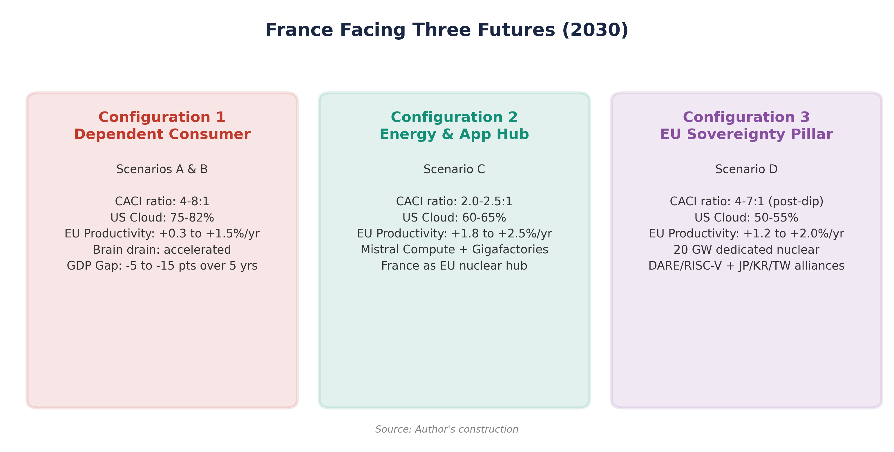

6.2.1 Large groups: constrained beneficiaries
Large French companies (CAC 40 and SBF 120) are the primary short-term beneficiaries of AI and the most exposed to medium-term dependence. They have the budgets to access the US cloud and the teams to deploy AI, but this adoption reinforces vendor lock-in with each iteration. The cost of migration (switching cost) from a complete cloud ecosystem (AWS to OVHcloud, for example) is estimated at 12-18 months of development and millions of euros in re-architecture, making it economically irrational except under strong regulatory constraint. Under scenario A, they continue to adopt AI via the US cloud, accumulating increasing dependence but benefiting from real productivity gains. Under scenario B, the sudden increase in compute costs puts them in a dilemma: absorb the extra costs (margin compression) or slow down AI projects (loss of competitiveness).


6.2.2 Industrial SMEs and mid-caps: progressive exclusion
SMEs and mid-sized companies represent the French industrial fabric (4,000 mid-caps, 140,000 SMEs). Their access to cutting-edge AI is already constrained by costs: training a specialized model costs several hundred thousand euros, out of reach for most SMEs without subsidies. McKinsey (December 2025) observes that AI productivity gains are concentrated in large companies, creating an intra-European productivity gap between adopting and non-adopting companies.[6] Under scenario B, rising compute costs widen this gap: SMEs give up on cutting-edge AI and opt for degraded solutions (lightweight open-source models, local inference on limited hardware), progressively losing competitiveness against US SMEs that benefit from domestic compute exempt from tariffs.
EuroHPC AI Factories, designed to give priority access to startups and SMEs, could mitigate this effect (scenarios C and D). But their total capacity (approximately 475,000 GPUs, the order of magnitude of a single US hyperscaler) is insufficient to serve the entire European economic fabric. The gap between the public supply of compute and market demand is structurally deficient.[7]


6.2.3 French AI startups: between championship and dependence
The French AI startup ecosystem is the most dynamic in Europe. Mistral AI, valued at 11.7 billion euros (September 2025 Series C, led by ASML), is the European champion of generative AI.[8] The company has raised a total of 2.8 billion euros, employs about 700 people, and is developing Mistral Compute, a sovereign cloud platform with 18,000 Nvidia Grace Blackwell GPUs deployed in a 40 MW data center in Essonne, powered by French nuclear energy.[9] In February 2026, Mistral announced a 1.2 billion euro investment for a data center in Sweden (Borlänge), and the acquisition of the startup Koyeb to strengthen Mistral Compute.[10]
The Mistral case illustrates both the potential and the limits of European AI sovereignty. Potential side: the company proves that a European startup can reach global scale, attract massive investments (ASML, Nvidia, Bpifrance, a16z), and build its own compute infrastructure. Limits side: Mistral remains dependent on Nvidia GPUs (no European alternative for AI accelerators), initially used Microsoft Azure and Google Cloud for training, and its investor Microsoft holds a strategic position (conversion of a 15 million EUR investment). The company illustrates application-level sovereignty (models, platforms, services) without hardware-level sovereignty—precisely the junior partner position described in scenario C.
Beyond Mistral, the French ecosystem includes Hugging Face (valued at 4.5 billion dollars, model hosting platform, headquartered in Paris but infrastructure in the US), LightOn (specialized models for enterprise), H Company (formerly Holistic AI), Owkin (AI for healthcare), and Scaleway (French sovereign cloud, first European access to Nvidia Blackwell GPUs). AI funding in Europe grew by 55 percent in the first quarter of 2025, with 12 new unicorns in the first half. France is for the fifth consecutive year the primary European destination for foreign AI investment.[11]


6.2.4 Public sector and defense: the sovereignty imperative
The French public sector represents a special case. The Ministry of the Armed Forces launched GenIAl.intradef in February 2025, a secure conversational agent based on Mistral AI.[12] The Directorate General of Armaments (DGA) and ANSSI are working on classification frameworks for sovereign AI. For defense and intelligence, dependence on the US cloud is unacceptable regardless of the scenario: classified workloads must be executed on national infrastructure. This captive market provides a guaranteed demand base for sovereign cloud providers (OVHcloud S3ns, Thales S3ns, Scaleway), but its size remains limited compared to the commercial market.


6.3 Second-order effects
6.3.1 Brain drain and capture of AI talent
Compute asymmetry produces a talent attraction effect toward the United States. European AI researchers and engineers are attracted by: (i) US compensation packages (salary + equity), which are structurally superior to European standards; (ii) access to cutting-edge compute, a necessary condition for frontier research; (iii) the ecosystem (proximity to Big Tech, VCs, research community). Martens (Bruegel) notes that personnel cost (salaries + equity) is often the most important component of the cost of developing an AI model, and that US companies compete fiercely to recruit the world's best talent.[13]
This brain drain directly weakens the L(r) factor of European CACI. It is partially compensated by the excellence of French training (ENS, Polytechnique, INRIA, Parisian universities) which form a continuous flow of talent—but a significant proportion leaves for the United States after their PhD. Mistral AI, founded by alumni of DeepMind and Meta, illustrates the possibility of retaining (or repatriating) talent, but it is the exception rather than the rule. Under scenarios C and D, the deployment of Gigafactories and Mistral Compute could create an ecosystem attractive enough to retain more talent.
6.3.2 R&D Offshoring
Compute asymmetry produces pressure to offshore the most calculation-intensive R&D activities. This phenomenon is already observable: the largest AI R&D centers of European companies are often located in the US (Bosch AI in Sunnyvale, SAP AI in Palo Alto, DeepMind in London but owned by Google). Under scenario B, this pressure intensifies: 15 to 20 percent of critical AI projects could be offshored to the United States (notably to areas near Nvidia/TSMC fabs in Arizona, or Virginia data centers). Under scenarios C and D, offshoring is mitigated by the availability of local compute, but does not disappear completely because the FLOP cost gap remains positive in favor of the United States in all scenarios.
6.3.3 Normative fragmentation: the AI Act as a double-edged sword
The European AI Act, in progressive application since 2024, produces ambivalent effects in the context of US protectionism. On one hand, it creates additional compliance costs for European companies (model transparency, copyright management in training data, security audits). Draghi (2024) observed that European data restrictions create high costs and slow down model training. Martens (Bruegel, 2025) notes that the AI Omnibus risks prolonging regulatory uncertainty for at least two more years.[14]
On the other hand, the AI Act creates an entry barrier for US competitors—an unintended protectionist effect that could favor European actors compliant by design (Mistral, whose transparent and auditable models are naturally aligned with the AI Act). The Code of Practice on copyright and training data, published in July 2025, imposes constraints that closed models (OpenAI, Anthropic) have more difficulty satisfying. Under scenarios B and D, where geopolitical mistrust is maximal, the AI Act could become a de facto tool for European preference, analogous to the GDPR which favored the emergence of European solutions in personal data processing.
6.4 The France AI ecosystem: unique assets and structural vulnerabilities
The differentiated analysis of the preceding sections allows for a balance sheet of France's specific assets and vulnerabilities in the context of AI protectionism, presented in Table 15.
On the assets side, France has unique comparative advantages in Europe: a nuclear fleet (65-70 percent of the electricity mix) that produces competitive and low-carbon electricity, a generative AI champion (Mistral AI valued at 11.7 billion EUR) with ASML as an industrial partner, centers of excellence in training (ENS, Polytechnique, INRIA, CNRS/IDRIS, more than 150 startups passed through Jean Zay), 109 billion EUR in private AI commitments announced at the February 2025 Summit, and the top European destination for foreign AI investments (five consecutive years).
On the vulnerabilities side, France remains structurally dependent: absence of an AI hardware champion (no GPU/ASIC design), limited installed compute (about 5 percent of the global total for France alone, US/France ratio of the order of 30:1—consistent with the US/EU(13) raw ratio of 17.6:1 since France represents the majority of installed EU compute), post-doctoral brain drain to the US, slow permitting (24+ months), electricity grid under tension (+10 GW needed according to RTE), US cloud dependence on 70-80 percent of AI workloads, and AI Act compliance surcharges in a context of regulatory uncertainty (omnibus 2+ years).
6.5 Synthesis: France facing three futures
The analysis in this chapter converges toward three possible configurations for France by 2030, corresponding to the trajectories of the scenarios in Chapter V.
Configuration 1: Dependent Consumer (scenarios A and B). France adopts AI via the US cloud, gains productivity in the short term, but accumulates structural dependence that places it in a position of vulnerability to any US hardening. Large groups prosper but are captive; SMEs are progressively excluded from cutting-edge AI; the most promising startups offshore their infrastructure to the United States. Brain drain accelerates. The productivity gap with the United States widens by 5 to 15 cumulative points over five years.
Configuration 2: Energy and Application Hub (scenario C). France exploits its nuclear advantage to become the energy center of gravity for AI in Europe. Mistral Compute and Gigafactories provide competitive local compute for inference and fine-tuning. French companies are sovereign in application but dependent on US hardware. On raw compute, the US/EU ratio drops from 17.6:1 in 2025 toward 8-10:1 in 2030; on CACI Power Mode, the gap closes from 3.46:1 toward 2.0-2.5:1. Brain drain is slowed by the existence of an attractive local ecosystem.
Configuration 3: Pillar of European Sovereignty (scenario D). US protectionism catalyzes an unprecedented mobilization. France, thanks to its nuclear power, its excellent training, and Mistral, becomes the pillar of a European technological sovereignty effort. Massive investment (20 GW dedicated nuclear, RISC-V/DARE, Japan-Korea alliances) creates the conditions for a long-term catch-up, but the transition period (2026-2028) is painful. Execution risk is maximal: each year of delay in infrastructure prolongs vulnerability.
Chapter VII will elaborate on the strategic recommendations corresponding to each of these configurations, distinguishing short-term measures (suitable regardless of the scenario) from structural investments (dependent on the chosen trajectory).
Table 14. French sectoral exposure to AI compute asymmetry.
Source: Author's construction, calibration on the public dashboard (April 2026).
Sector | Compute Intensity | Data Sensitivity | US Cloud Dependence | Scenario B Risk
Finance | High | Very high | 70-80% | Lock-in + surcharges: -3 to -5 pts productivity/yr
Auto/Aero | Very high | High | 60-70% | Slowed simulations, R&D offshoring
Health/Pharma | High (drug disc.) | Maximal | 40-60% | Offshored drug discovery to US
Robotics/Indus. | High | Moderate | 50-65% | Slowed innovation + energy surcharge
Defense/Space | Very high | Critical | Variable | Maximal strategic vulnerability

Table 15. Balance of France's assets/vulnerabilities in the context of AI protectionism.
Source: Author's synthesis, calibration on the public dashboard (April 2026).
France's Assets | France's Vulnerabilities
Nuclear energy (65-70% of mix): competitive cost, low carbon, data center deployment | Absence of AI hardware champion (no GPU/ASIC design): Nvidia/AMD dependence
Generative AI champion: Mistral AI (11.7B EUR val., Mistral Compute, ASML partner) | Installed compute: France about 5% of global; raw US/France ratio around 30:1
Excellence in training: ENS, X, INRIA, CNRS/IDRIS (Jean Zay, 150+ startups) | Post-doctoral brain drain to US (salaries + equity + compute)
109B EUR in private AI commitments (February 2025 Summit) | Slow permitting (24+ months), saturated electricity grid (+10 GW RTE need)
1st EU destination for foreign AI investments (5 consecutive years) | US cloud dependence: 70-80% AI workloads on AWS/Azure/GCP
AI Act: Mistral's compliance by design (open-source, auditability) | AI Act: compliance surcharges, regulatory uncertainty (omnibus 2+ years)

Notes
1. Mistral AI (2025), partnership press releases. AXA and BNP Paribas are among the first enterprise adopters of Mistral in France. See NVIDIA Blog (June 2025), 'France Bolsters National AI Strategy With NVIDIA Infrastructure'.
2. IMF (March 2025), op. cit. Financial services are among the sectors with the highest AI exposure (Felten and Eloundou indices), with documented microeconomic gains of 20-40 percent on compliance and risk analysis tasks.
3. Mistral AI / Wikipedia FR (2026). Stellantis (formerly PSA and Fiat-Chrysler) signed a 100 million EUR partnership with Mistral AI in April 2025. CMA CGM also concluded a 100 million EUR partnership.
4. Sanofi (2024-2025), press releases. Owkin, founded in Paris in 2016, specializes in AI for clinical research and drug discovery.
5. McKinsey (January 2026), 'Transforming Europe: Bold Moves to Lift a Continent'. Novo Nordisk: over 8.2 billion USD in R&D in 2024, use of digital twins and AI for drug discovery.
6. McKinsey (December 2025), 'Accelerating Europe's AI Adoption'. The report observes that AI productivity gains are concentrated in 'lighthouse' companies, with gains reaching 40 percent in labor productivity and 50 percent in lead time reduction.
7. Segler Consulting (June 2025), 'Europe's AI Gambit'. Total EU public capacity is estimated at about 57,000 accelerators in 2025, an order of magnitude lower than the infrastructure of a single US hyperscaler.
8. Mistral AI (September 2025), Series C: 1.7 billion EUR raised, 11.7 billion EUR valuation. ASML lead investor (1.3 billion EUR for approx. 11%). Other investors: DST Global, a16z, Bpifrance, General Catalyst, Index Ventures, Lightspeed, Nvidia.
9. Introl Blog (December 2025), 'France's AI Sovereignty Push'. Mistral Compute: 18,000 Grace Blackwell GPUs, 40 MW data center in Essonne (hosted by Scaleway/Eclairion), powered by nuclear energy. Planned launch 2026.
10. Mistral AI / Wikipedia FR (February 2026). Borlänge data center (Sweden): 1.2 billion EUR, planned for 2027, via EcoDataCenter (renewable energy). Acquisition of Koyeb (February 17, 2026) to strengthen Mistral Compute's serverless offering.
11. Dealroom (2025), cited in FinTech Weekly. AI funding in Europe +55% in Q1 2025, 12 new unicorns in H1 2025. France has been the #1 EU destination for foreign AI investments since 2020.
12. Ministry of the Armed Forces (February 2025), launch of GenIAl.intradef. Secure conversational agent based on Mistral AI, deployed on sovereign infrastructure.
13. Martens, B. (2024), Working Paper 18/2024, Bruegel, op. cit. AI personnel cost (salaries + equity) is often the most important component of model development, and US companies offer structurally superior packages.
14. Martens, B. (2025), 'The European Union Needs More Than the Digital Omnibus to Make Digital Services Competitive', Bruegel. The AI Omnibus, intended to accelerate regulatory changes, is likely to take at least a year to be adopted, plus another year for complementary guidelines.

License and Disclaimer. This work, 'AI for Americans First', is made available under the terms of the Creative Commons Attribution-NonCommercial-ShareAlike 4.0 International (CC BY-NC-SA 4.0) license. You are free to share and adapt the material for non-commercial purposes, provided you properly attribute the work to Fabrice Pizzi (Université Paris-Sorbonne) and distribute your contributions under the same license. This document is provided for educational and research purposes only.
Public Dashboard : https://mo0ogly.github.io/America-First-IA/dashboard/
Repository : https://github.com/mo0ogly/America-First-IA
AI for Americans First - Fabrice Pizzi - Chapter VI

